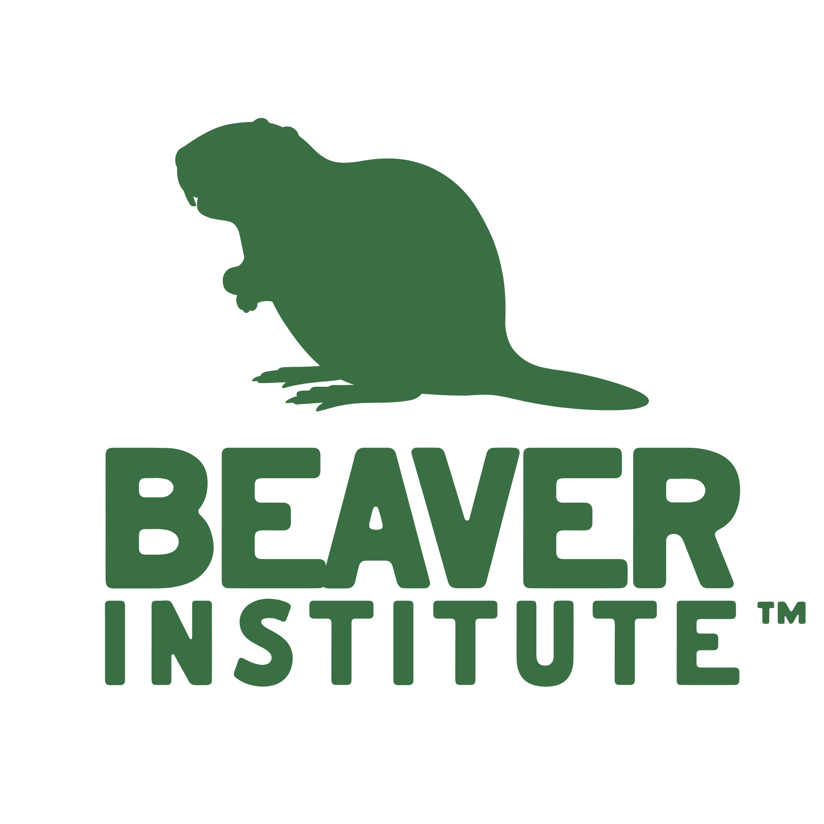
Position Description: Executive Director
Organization: Beaver Institute (BI)
Location: Remote (North America)
Reports to: Board of Directors
Anticipated Start Date: Summer 2026
Items to be Submitted in Application: CV/resume, cover letter, and list of three current references.
Organizational Overview: The Beaver Institute (BI) is the only national non-profit dedicated to fostering ecological balance through beaver coexistence and restoration. Founded in 2017, BI has experienced rapid growth, moving to the forefront of climate-resilient ecosystem management. We empower individuals and organizations, including regional coalitions, across North America through non-lethal management training, financial assistance for landowners, scientific research, and national advocacy. As we scale to meet continental demand, we are seeking a dynamic Executive Director to transition the organization from its successful founding phase into a professionally managed, high-impact organization.
The Role: The Executive Director will provide the strategic, operational, and financial leadership necessary to support BI’s sustainability and growth. This is a role for a leader who thrives in a fast-paced environment and who is equally comfortable orchestrating high-level partnerships, developing systems and processes, and nurturing and managing the team. The ED will lead a virtual team of three dedicated employees, five part-time contractors, and volunteers in a virtual setting while inspiring and engaging partners and funders.
Salary Range: $110,000 - $130,000, depending on experience.
Key Responsibilities
1. Strategic Leadership & Governance
- Vision Alignment: Implement the long-term strategic plan, ensuring all programming remains aligned with the Board’s vision.

- Board Partnership: Collaborate with the Board of Directors to enhance governance, establish working committees, and provide transparent reporting on organizational health. Attend regular meetings with the Board to discuss progress and troubleshoot challenges.
- Organizational Evolution: Oversee the building and maintenance of sufficient internal systems to support a growing, continental-scale organization composed of remote-work employees.
2. Financial & Operational Excellence
- Fiscal Stewardship: Assume full P&L responsibility, including budget development, forecasting, and ensuring the organization operates with high financial integrity and transparency.
- Systems Development: Continue to build and maintain the administrative "backbone" of the organization (HR, IT, and internal communications) to support a remote workforce. Compliance: Ensure absolute adherence to federal and state non-profit regulations and reporting requirements.
3. Fundraising & Strategic Growth
- Revenue Diversification: Design and execute a comprehensive development strategy focusing on individual major donors, foundations, government entities, and corporate partnerships.
- Advocacy & Partnerships: Act as a primary liaison with state/federal natural resource agencies, Tribal nations, academic researchers, and conservation NGOs.
- Community Engagement: Serve as the "Face of BI," representing the organization at national conferences, in the media, and at community-building events.
4. Flagship Event Oversight (BeaverCON)
- Strategic Production: Oversee the successful execution of BeaverCON, ensuring it remains the world’s premier conference for beaver advocacy and science.
- Impact & Sponsorship: Lead high-level networking and sponsorship efforts to ensure the conference provides a lasting impact on the regional hosting locations.
5. Staff Leadership & Culture
- Team Empowerment: Directly manage and mentor the Head of Operations and programmatic staff, fostering a culture of accountability, teamwork, respect, creativity, and growth. Complete annual reviews for each staff member in a timely and professional manner.
- Resource Management: Optimize the use of contractors and staff to meet organizational priorities.
Qualifications & Traits
- Education: Bachelor’s degree in Business Administration, Public Administration, Environmental Science, or a related discipline required. An advanced degree, including an M.S., M.A., or PhD in a relevant field, a J.D., or Certified Association Executive (CAE) designation is highly preferred.
- Experience: A minimum of five years as a nonprofit executive director or senior manager of an NGO division. Experience in planning, budgeting and executing a national conference for stakeholder audiences, preferably within a conservation or environmental non-profit. Prior experience working in and managing a remote workforce. Proven track record of scaling an organization from a local/regional focus to a national one is preferred. Prior experience working with beaver (Castor spp.) in a professional context is strongly preferred.
- Field Knowledge: Demonstrated ability to build relationships across the conservation field, including experience navigating the complexities of state and federal wildlife or natural resource policy.
- Communication: Exceptional written and verbal skills; an inspiring public speaker who can translate complex ecological information into compelling narratives for donors and the communities we serve.
- Technical Proficiency: Technologically savvy with experience managing remote teams using cloud-based tools (Google Workspace, CRM systems, NordPass, and financial software).
- Core Traits: Results-oriented, pragmatic, and self-directed. Ability to remain open to opposing views while making decisive, mission-first decisions.
Apply: Send together as one combined pdf a cover letter saying why you are interested in the position, along with your resume and a list of three current references. Email the pdf package to: jobs@beaverinstitute.org
Deadline: Priority review begins June 15, 2026. Closing deadline is June 24, 2026, at 5 pm ET and no materials will be accepted after that deadline.

