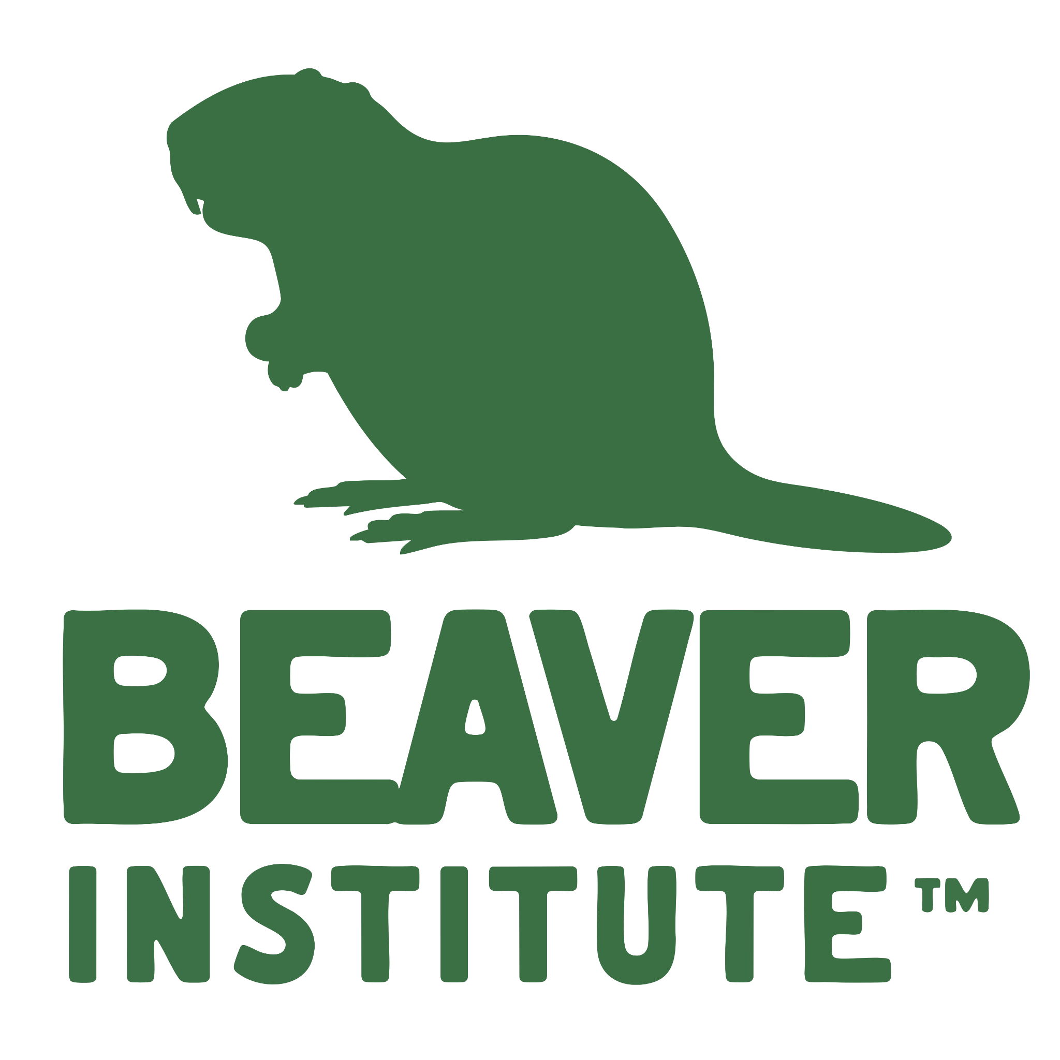
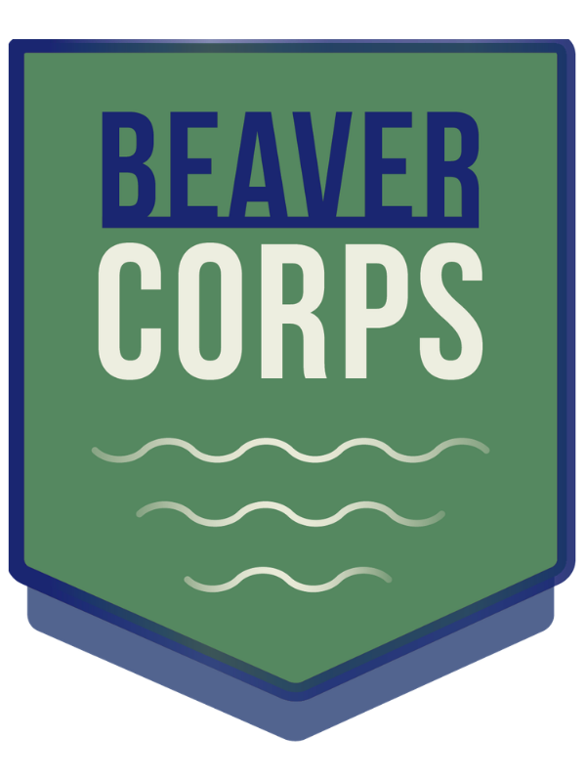
Beaver Institute Inc.
14 Mountain Road
Southampton, MA 01073
www.beaverinstitute.org
(413) 695-0484
BeaverCorps Grant Program
Application Form

Thanks to generous funding from the Animal Welfare Institute and others, Beaver Institute has created a grant program to financially incentivize landowners to hire BeaverCorps professionals to nonlethally resolve beaver issues and restore wetlands. The goal of the program is to increase beaver wetlands to improve climate resilience.

Who can participate?
Any individual, town, business, or organization in North America interested in hiring a BeaverCorps Professional to nonlethally resolve conflicts or restore wetlands. Only one grant application per BeaverCorps member/per year will be accepted.
Grant amount?
Applicants are eligible for up to 1/3 of the total project costs for any nonlethal conflict prevention or beaver mimicry wetland restoration project. Maintenance costs for devices are the applicant’s responsibility and not applicable for funding.
What are the criteria?
A willingness of the landowner/client to avoid beaver removal, and/or encourage beaver occupancy at a site. Financial investment is required from the landowner/client. Approval from all permitting authorities is also required.

How do I request assistance? First, obtain a professional estimate for the installation of the beaver flow device. Then send this completed application to the Beaver Institute for consideration.

Submit this application to:
molly@beaverinstitute.org or aaron@beaverinstitute.org

BeaverCorps Grant Program Application Form

Landowner Information

Date: Click or tap to enter a date. | Name: Click or tap here to enter text.
Email: Click or tap here to enter text. | Phone Number: Click or tap here to enter text.
Address: Click or tap here to enter text.

BeaverCorps Member Information
Name: Click or tap here to enter text. | Email: Click or tap here to enter text.

Project Information

Project Address: Click or tap here to enter text.

Description of the problem(s) and your goals/define success:
Click or tap here to enter text.

BeaverCorps Grant Program Application Form Continued

BeaverCorps Member proposed solution? (attach site assessment/work proposal)
Click or tap here to enter text.

Estimated wetland acreage impacted: Click or tap here to enter text.

Total cost estimate of water flow device (attach BeaverCorps member’s official cost estimate or invoice): $Click or tap here to enter text.

Your (landowner) contribution: $Click or tap here to enter text.

Grant amount requested: $Click or tap here to enter text.

If you are requesting more than 1/3 of the flow device cost, please explain your financial hardship here:
Click or tap here to enter text.

Note: If approved you must submit before and after pictures of the project, project completion invoice, and submit 6-month and 1-year maintenance reports.
Please return this completed application and photos to: molly@beaverinstitute.org or aaron@beaverinstitute.org
We will notify you promptly of the grant committee's decision.

